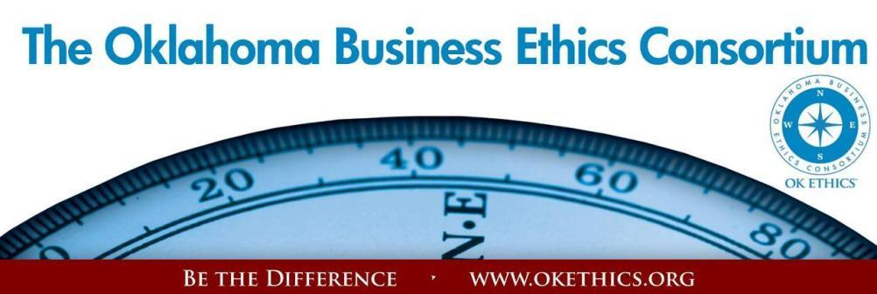

ENTERING OUR TENTH YEAR OF PROMOTING OKLAHOMA VALUES OF INTEGRITY AT WORK!
Agenda – January 9, 2013
- Welcome – Garyl Geist, Chief Operating Officer, Oklahoma Allergy & Asthma Clinic;
President, OK Ethics Consortium State Board of Directors
- Kudos –
- New Members: Frontier: Oklahoma Quality Foundation & the Salt & Light Leadership Team. Scouts: Shannon Meyer with Visiting Angel; John Chasteen with The Chasteen Group & Brad Williams with The Plexus Group; Beverly Palmer with The Oklahoma County DA’s Office
- Volunteer Appreciation

- Announcements: Shannon Warren, Founder, OK Ethics
- ATTENTION MEMBERS: RECRUITING GOALS FOR FY12-13 – PLEASE HELP OK ETHICS FLOURISH!
- 6 NEW LEADING MEMBERS - $1500 LEVEL
- 10 NEW FRONTIER MEMBERS - $400 LEVEL
- 10 NEW SCOUT MEMBERS - $75 LEVEL
Did you know that 501c3, non-profit organizations can join for free at the Frontier level?
- Upcoming Events
- Intentional Interaction Discussion: Please ask each person at your table to share responses to the following questions:
- What is the main obstacle that hinders cooperation/collaboration in the workplace?
- Based on personal experience, what is the best way to overcome these obstacles?
Note: OK Ethics encourages interaction among our members for the purpose of building relationships with others who share an interest in promoting Oklahoma values of integrity at work. This is not an appropriate forum for sales.
- Introduction & Guiding Principle – David Prater, Oklahoma County District Attorney
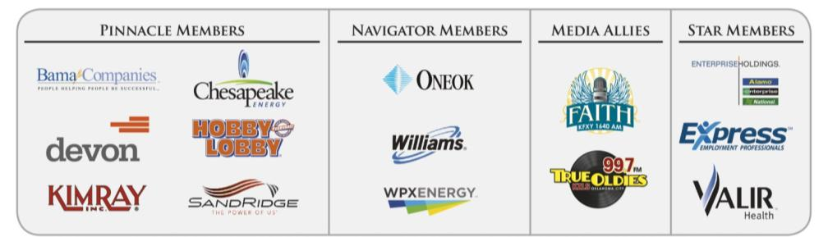
Keynote: Wes Lane, President of Salt and Light Leadership Training, Inc., Author of Amazingly Graced, Chairman of Department of Human Services Commission, Former Oklahoma County District Attorney.
Book signing immediately following program; Make $10 checks payable to Mardel,
Credit cards also accepted
REMINDER: PLEASE PICK UP CPE’S AT CONCLUSION OF EVENT.

VOLUNTEER APPRECIATION:
OK Ethics relies primarily on volunteers to achieve the organization’s successful pursuit of Oklahoma’s values of integrity at work. It takes leadership and teamwork to host these exciting events and we salute your dedication in achieving OK Ethics’ mission! Listed below are today’s volunteers who consistently provide service to our members:

Agendas: Many thanks to the volunteers from Metro Technology Centers who provide our monthly agendas.

Ambassador Team: These friendly people welcome our guests each month and assist in helping them locate seats. They also arrive early to help distribute agendas and assist with name tags.
John | Burnett | Character First | Ambassadors (Lead – Team 2)
Jamie | Gorman | Hyde & Company CPA’s | Ambassadors
Jacob | Pasby | Arnold Oil Properties | Ambassadors
Bill | Turner | Valir Health | Ambassadors
Nancy | Hyde | Hyde & Company, CPA's | Ambassador (Executive Team)
Ben | Robinson | SentryOne LLC | Ambassadors (Executive Team)
Tom | Shehan | Nextep Inc. | Ambassadors (Executive Team)
Registration Team: These dependable individuals diligently record our guests’ attendance and handle the collection of fees:
Mark | Neumeister, CPA | D. R. Payne & Associates | Registration Chairperson
Mary | Vaughan, CPA | JMA Energy | Guest Registration (Cash & Visitors)
Marvinette | Ponder | Devon Energy | Pre-paid Registration - Lead
Lucius | Crandall | SandRidge Energy | Pre-paid Registration
Brandy | Weldon | SandRidge Energy | Pre-paid Registration

Special Initiatives:
Michael | Mount | Oklahoma Accountancy Board | CPE's
Susan | Pate | Stinnett & Associates | Accountant
Jamie | Potter | Eide Bailly LLC | Facilities & Logistics Chair
Jalisha | Petties | OK Ethics | Member Care Coordinator
Anna | Rosenthal | OK Ethics | Special Projects & Name Tags
Shirley | Mears | Champlin Broadcasting | Announcements on the Morning Drive (99.7)

TUNE IN! Our own Bob Byrne and Shirley Mears featured on the morning drive for True Oldies Channel FM 99.7 – Tune in between 7:00 and 8:00 a.m. to learn more about Oklahoma’s legacy! Also, hear interviews with speakers thanks to Champlin Broadcasting and the folks with the Oklahoma Heritage Association who provide the research for our historic profiles!
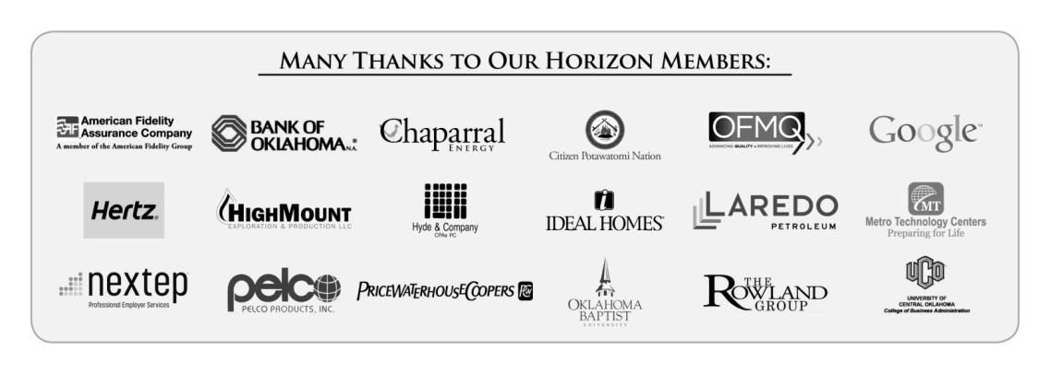
New Member Appreciation:
We appreciate all that our contributors do to promote business ethics in our Oklahoma communities. Members’ support resulted in the following achievements last year:
- An average of 450 business leaders and professionals in OKC & Tulsa attend our monthly programs focused entirely on business ethics. That’s an increase of nearly 100 participants this past year!
- Thanks to you, we are now able to bring in internationally-known speakers, in addition to programs presented by local heroes. In November, we kicked off a year-long celebration toward our tenth anniversary with keynote speaker, Harry Paul. He is one of the authors for the best-selling book, Fish!
- This year, we found it necessary to retain some part-time workers, but most of our work continues to be performed by a dedicated group of volunteers. By spreading the work among these passionate individuals, we are able to maintain the lowest possible overhead while continuing to deliver valuable services to our business community. The ROI is significant as we provide numerous continuing education programs that are consistently high in quality.
- Finally, our outreach to university students has greatly increased. Part of your membership dues are earmarked to sponsor student ethics activities on thirteen Oklahoma campuses and our Foundation sponsored a Statewide Educators Ethics Symposium that was attended by approximately 70 academic leaders representing nearly 20 educational institutions.
We are extremely proud of our winning student teams from the Regional Ethics Bowl in San Antonio! Oklahoma Christian (1rst & 3rd places), The University of Oklahoma (2nd place) and Oklahoma City University (4th place) will participate in the upcoming national event!

HELP GET THE WORD OUT: PLEASE POST THIS ON YOUR COMPANY’S BULLETIN BOARD
Upcoming Events: Oklahoma City Chapter

Wednesday, February 13, 2012  Petroleum Club - OKC | Thursday, March 7  Petroleum Club – OKC
“What in the World is Going On?”  presented by  Lori Tansey Martens  President & Founder,  International Business    Ethics Institute  Washington D.C.  Recommended for 1 CPE in Ethics | Dr. Marilyn Tam    Former CEO of Aveda,  President of Reebok Apparel &  Vice President of Nike  Born in Hong Kong, this author and entrepreneur overcame an abusive childhood. She traveled to the U. S. where she has built and led several companies. Dr. Tam is listed as one of the four most prominent names  in Ethical Business.  Recommended for 1 CPE in Ethics

Upcoming Events: Tulsa Chapter

Thursday, January 24  Doubletree Hotel – Downtown Tulsa | Thursday, February 21  Doubletree Hotel – Downtown Tulsa
“Surviving the Toxic Workplace”    presented by author  Dr. Linda Durre | 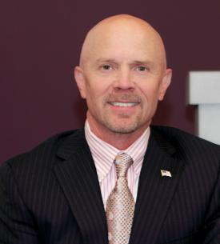  “How to Build a Winning Organization”  Presented by  Brad Frank,  President of  Tulsa Tube Bending

Programs Focused on Integrity - (Not affiliated with OK Ethics)

Since the beginning, OK Ethics members have been inspired by our friendship with Character First. Leaders with this organization provided the wisdom and insight for OK Ethic's Guiding Principles. Go to www.characterfirst.com to learn more about tools to help you integrate character and ethics into your organizational culture, or contact John Burnett at 405-815-0001
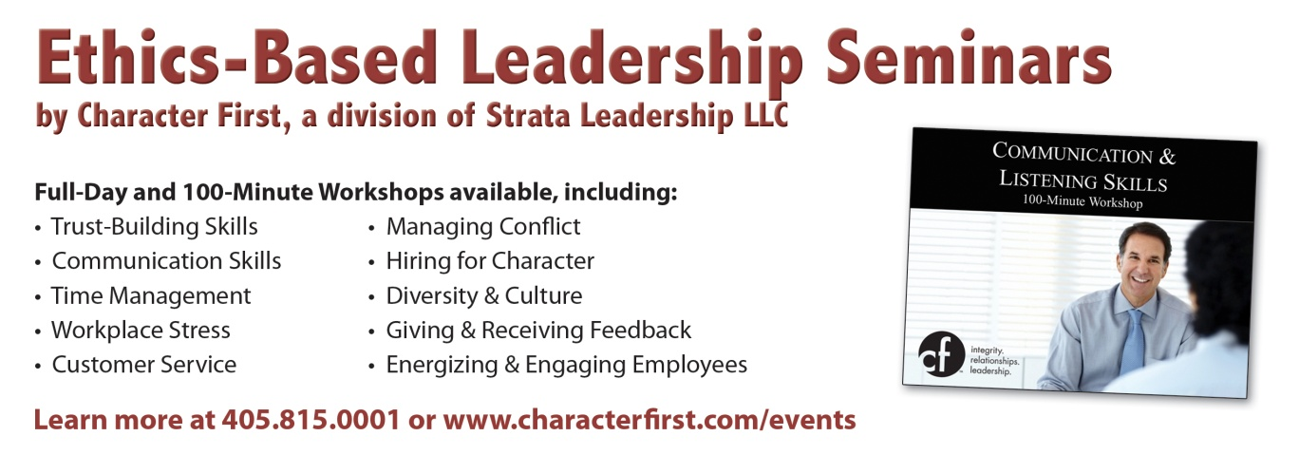

Character Council of Central Oklahoma …cultivating good character

The Character Council of Central Oklahoma is an organization that educates, equips and empowers others to create a culture of good character within Central Oklahoma. Their vision is that Central Oklahoma will become a model community of good character.

Overcoming Contention & Divisiveness
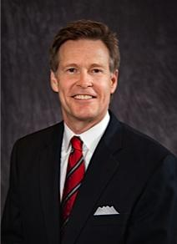
Presentation by Wes Lane, President of Salt and Light Leadership Training, Inc., Author of Amazingly Graced, Chairman of Department of Human Services Commission, Former Oklahoma County District Attorney.
Born and raised in Oklahoma City, Wes received his undergraduate and law degrees from the University of Oklahoma.
Wes is married to Dr. Lori Hansen Lane, a facial plastic surgeon. They have one son, Derrick, an Oklahoma County deputy sheriff who has served his country on two tours of infantry duty in the Middle East and now flies Chinook helicopters for the Army National Guard. Derrick and his wife, Soniya are parents to Wes and Lori’s granddaughter, Talia.

- Process Starts with Self-Awareness:
The ultimate value of life depends upon awareness and the power of contemplation rather than upon mere survival. - Aristotle

The unexamined life is not worth living. - Socrates

#1 What is your belief system or worldview?
- Everybody has one

#2 When talking about overcoming contention/divisiveness
– really talking about making peace.

- Why can’t we get along?
OVERCOMING the obstacles:
- Who am I? Are my anchors secure?

Character Quality from Character First:
- Security v. worry: Structuring my life around that which cannot be destroyed or taken away
  - To what are you tethered?
  - The issue of identity – who are you and what do you worship?
    - This not necessarily a religious comment
    - What we worship is that to which we bend the knee
      - Money, fame, reputation, power, pride, God – we all worship something
      - Do you worship your religion? Your political party?
Your job?
      - When you stop being your job title, how will you do?

I will give thanks to You, for I am fearfully and wonderfully made… My frame was not hidden from You… And in Your book were all written the days that were ordained for me, when as yet there was not one of them. Psalm 139:14-16
- Standing on the rock of small kindnesses – a personal journey
This is my simple religion. There is no need for temples; no need for complicated philosophy. Our own brain, our own heart is our temple; the philosophy is kindness.
– The Dalai Lama; head of Tibetan Buddhists and recipient of the Nobel Peace Prize

- Whoa! Hold that thought!

The ability to subordinate an impulse to a value is the essence of the proactive person.― Stephen R. Covey, The 7 Habits of Highly Effective People: Powerful Lessons in Personal Change

Educate your children to self-control, to the habit of holding passion and prejudice and evil tendencies subject to an upright and reasoning will,and you have done much to abolish misery from their future and crimes from society.― Benjamin Franklin

Character Quality from Character First:
- Meekness v. Rage: Yielding my personal rights and expectations with a desire to serve (meekness = power under control)
  - It is self-restraint rooted in a recognition that it is not all about “you”;
again rooted in security rather than fear

- Mistakes, Misunderstandings & Plain Old Meanness:The Power of Forgiveness

Unforgiveness is the poison you drink every day hoping the other person will die…

Character Quality
- Forgiveness v. Bitterness: Clearing the record of those who have wronged me and not holding a grudge
  - Sometimes you must not only forgive, but ask forgiveness
  - Wrongs can be real or they can be perceived but it doesn’t matter because they are real to the one you’ve hurt
  - Some of you have people in your past that you have wronged and you know it. Don’t just apologize to them, ask their forgiveness.

It takes two for complete reconciliation, but you are only responsible for one – yourself

The weak can never forgive. Forgiveness is the attribute of the strong.
― Gandhi, All Men Are Brothers: Autobiographical Reflections
Key Points:
- In what do you place your security?
- If it’s all about “you”, don’t expect peace.
- You can never control the other fellow. Only yourself.
- If your happiness seems tied to how others treat you, go back to #1 again and this time be honest.
- Is there anyone in your life that actually has permission to tell you you are wrong? If not, there should be.
- Forgiveness v. unforgiveness = freedom v. slavery.
- Is your conduct consistent with the belief system you claim?
- The Golden Rule is still 24K great advice (do to others as you would have done to you).
- If you are keeping score, you will never really win.
- Would your employees say their workplace is a place of peace or strife?
- Since your child is probably going to grow up to be like you, will they be a person of peace or strife?

- THE BIG PICTURE – REFORMING OUR WORLD

- What does it take to seek the peace of a city?

“Through the efforts of passionate, committed members, the Oklahoma Business Ethics Consortium strives to establish Oklahoma as a state known for
high personal and corporate ethical standards.”
- OK Ethics Mission Statement

OK Ethics goal: we become a people of high ethical standards, i.e. people who do the right thing as a culture.

The presence of contention and divisiveness in a community at large is nothing other than the tangible, measureable presence of strife, discord, conflict, instability, even chaos and violence.

- Can we really make a difference?
There are three constants in life: change, choice and principles. - Stephen R. Covey
Imagine for a moment if in OKC:
- 25% of unmarried women were prostitutes
- If the wealthy people of this community did not give money to charity because they are overwhelmingly selfish and it’s not fashionable to be otherwise
- There was no such thing as charity fundraisers
- At the legislature, alcoholism was rampant – and fashionable (not uncommon for major political figures to be drunk on the house and senate floor)
- Drunkenness was rampant throughout the city
- There were neither governmental agencies nor private agencies stepping in to help the poor.
- Public entertainment contemplated acts of amazing cruelty to animals and public executions commonplace, including dissecting the bodies
- Popular belief was that God ordained the misery of the poor and there is nothing we can nor should do about it
- Imagine a world of brutality, misery
- A world in which the sugar in our tea was the result of thousands of slaves
- All of the drunkenness and brutality etc., had been going on for a century

And that was the world of London in the late 1700’s.
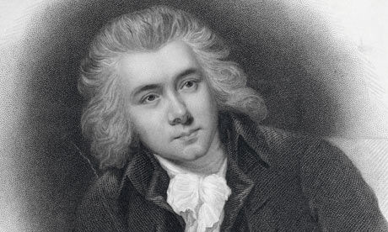
Group of London leaders from business, government and the church who determined that those facts were unacceptable. Their leader, William Wilberforce, determined that not only were they going to end slavery, but that they were also going to reform the moral character of the British Empire – and they did.

Wilberforce knew that government action against slavery was impossible without a massive shift in the moral attitudes, actions, and habits of the British people. - Don Eberly, “The Reformation of Manners”
William Wilberforce; Image Source: The Guardian, UK

- Doing What It Takes To Make Things Happen:
If a group of 18th century Londoners can solve a seemingly impossible systemic challenge (slavery), then a group of 21st century Oklahoma Cityans can too.

People are often unreasonable and self-centered.
Forgive them anyway.
If you are kind, people may accuse you of ulterior motives.
Be kind anyway.
If you are honest, people may cheat you.
Be honest anyway.
If you find happiness, people may be jealous.
Be happy anyway.
The good you do today may be forgotten tomorrow.
Do good anyway.
Give the world the best you have and it may never be enough. Give your best anyway.
For you see, in the end, it is between you and God. It was never between you and them anyway.― Mother Teresa

Character qualities from Character First:
Honor v. Disrespect: Respecting others because of their worth as human beings.
The capacity for getting along with our neighbor depends to a large extent on the capacity for getting along with ourselves. The self-respecting individual will try to be as tolerant of his neighbor's shortcomings as he is of his own.- Eric Hoffer

You should respect each other and refrain from disputes; you should not, like water and oil, repel each other, but should, like milk and water, mingle together. - Buddha

Justice v. Corruption: Taking personal responsibility to uphold what is pure, right and true.
- Human progress is neither automatic nor inevitable…Every step toward the goal of justice requires sacrifice, suffering and struggle; the tireless exertions and passionate concern of dedicated individuals. – Martin Luther King

Responsibility v. Unreliability: Knowing and doing what is expected of me

The man who complains about the way the ball bounces is likely to be the one who dropped it.
— Lou Holtz

In times like the present, men should utter nothing for which they would not willingly be responsible through time and eternity. — Abraham Lincoln; December 1, 1862 Message to Congress

In the long run, we shape our lives, and we shape ourselves. The process never ends until we die. And the choices we make are ultimately our own responsibility. — Eleanor Roosevelt

Humility v. Arrogance: Acknowledging that achievement results from the investment of others in my life.

The greatest lesson in life is to know that even fools are right sometimes.
– Winston Churchill
Benevolence v. Selfishness: Giving to others’ basic needs without having as my motive personal reward.
- Of neighborhoods, benevolence is the most beautiful. How can the man be considered wise who when he had the choice does not settle in benevolence.
- Confucius

REMINDER: PLEASE PICK UP CPE’S
AT CONCLUSION OF EVENT.
Interested in Receiving OK Ethics Monthly Meeting Notices?

OKC:
Contact Jalisha Petties, Member Care Coordinator
at (405) 889-0498 or via email okethics@yahoo.com

Interested in joining OK Ethics?
Contact Lynda Mobley, Vice President of Membership; Lynda.Mobley@oneok.com

LIKE OK ETHICS ON FACEBOOK


General Program Disclaimer:
Members of the Oklahoma Business Ethics Consortium frequently share information concerning various issues and developments that may have legal implications. The discussions, commentary, and handouts at Consortium meetings or presentations to other organizations are for general informational purposes only. They cover only some aspects of the subject topic, and do not constitute a complete legal analysis of the topic or how it might apply to any particular set of facts. Before taking any action based on information presented during a Consortium event, participants are encouraged to consult a qualified attorney. The observations and comments of presenters at Consortium meetings and networking are the views and opinions of the presenter and do not constitute the opinion or policies of the Consortium or any of its members. Presenters are respectfully requested to avoid profanity, preaching, politics, put-downs and self-promotion during their lectures

Oklahoma Business Ethics Consortium Guiding Principles
Adopted July, 2004
To ensure that the Consortium fosters positive characteristics of integrity in the successful achievement of its goals, these Guiding Principles were discussed and adopted (with revisions) during a milestone planning session held by Consortium leaders in Stroud on June 18, 2004. These principles were developed based on the Character First's values and philosophies.
I. Responsibility to Self and Others:
- Service:
  - Passion for promoting ethics and integrity
  - Encouraging the promotion of ethical behavior through personal actions and
  - Sharing ideas and resources
  - Responsibility and accountability for fulfilling the mission of the Consortium.
- Collaboration:
  - Achievement of common goals through the promotion of ethical, mutually beneficial relationships
  - Service to the Consortium over promotion of self-interest
  - Cooperation emphasized over competition in promoting ethical business conduct
  - Members collaborate by being constructively engaged in discussions regarding ethics
  - Seeking consensus in interactive discussions regarding ethical matters.
- Respect:
  - Members may become aware of confidential information shared by others in an effort to determine an ethical course of action. We ask members to be sensitive in recognizing and respecting the efforts made toward achieving ethical behavior. In that vein, public disclosure of this information is discouraged.
  - We respect other members and the process by:
    - Exhibiting listening skills and actively listening to discussions
    - Being open to other points of view and outcomes
  - We are an inclusive organization and demonstrate this by welcoming members who are in different stages of learning as applied to ethical behavior.
II. Lead with Integrity
- Dependability:
  - Members are asked to demonstrate their support of this initiative by consistently attending meetings.
- Initiative:
  - Recruiting other members who have demonstrated a desire to promote ethical behavior in their organizations.
  - Recognizing what needs to be done to help promote the Mission of the Consortium and taking action to assist in that effort.
- Honor:
  - Members are asked to honor the Consortium through the practice of integrity and ethical behavior in their business dealings.
  - We express gratefulness to our hosts, sponsors and speakers; as well as to those whose volunteer service makes OK Ethics a stronger organization.
  - Realizing that each of us is in a mode of continual learning, we demonstrate humility, care and compassion when sharing our thoughts and knowledge.
- Courage:
  - Speak the truth with confidence and encourage others to do the same.
III. Inspire Trust
- We serve and promote the cause of truth with integrity, objectivity and fairness to all persons.
  - We hold ourselves accountable by consistently honoring our word.
  - We extend trust abundantly to those who have earned it.
  - Trust, once earned, will not be taken for granted, manipulated or abused.

